Colorful Collage Cluster Bottles
By: Swelldesigner Aug 14, 2010

\
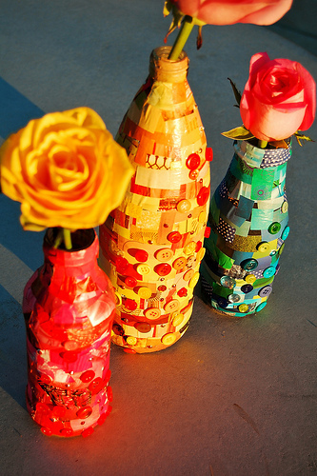Photo: farm5.static.flickr.com
Here's a fun and colorful project to finish out summer with! I love bright colors and I love to collage. I thought I'd mix the two along with my love for embellishments to create this easy DIY project. It's a great way to make something super pretty on the cheap! Here's how you do it!
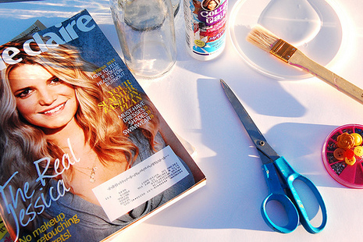Photo: farm5.static.flickr.com
Gather your supplies. I used various magazines, different sized and cleaned glass jars, Collage Pauge® Instant Decopauge, lid or plate, scissors,brush, and various embellishments including buttons and Tulip® Glam-It-Up!™ Iron-On Crystals™. I also used Aleene's® Original Tacky Glue, but I forgot to show it in the photo.
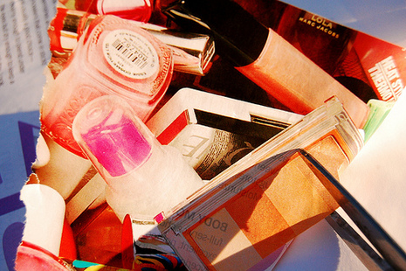Photo: farm5.static.flickr.com
Cut out various images from magazines. Choose a color scheme like that is in the same color family for the monochromatic look.
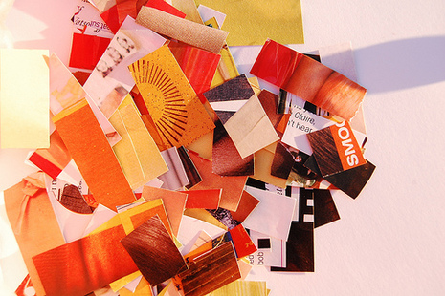Photo: farm5.static.flickr.com
The magazine clippings shouldn't be too large, more around .5" to 1" in width and height.
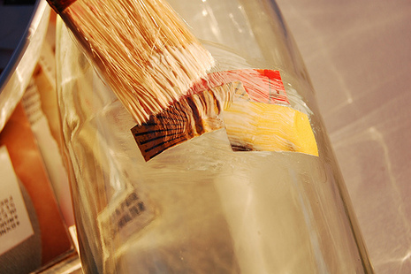Photo: farm5.static.flickr.com
Dip brush in Collage Pauge® Instant Decopauge and add a layer of medium to both front and back of clipping and adhere to jar.
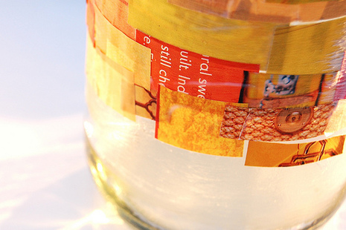Photo: farm5.static.flickr.com
Overlap strips of paper until entire jar is covered.
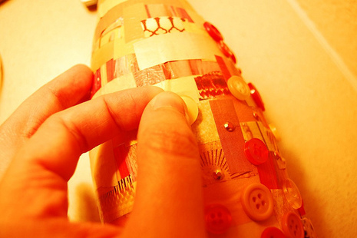Photo: farm5.static.flickr.com
Adorn bottle as desired with embellishments. Let dry.
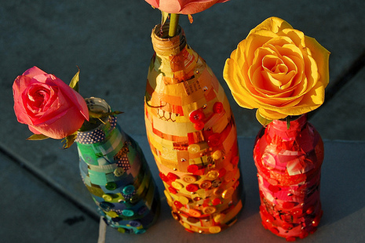Photo: farm5.static.flickr.com
I hope you enjoyed this project!

