Cat Breed
Choose a specific cat breed. Use the picture below to color the cat based on the breed you have chosen. Fill in the information on the back.
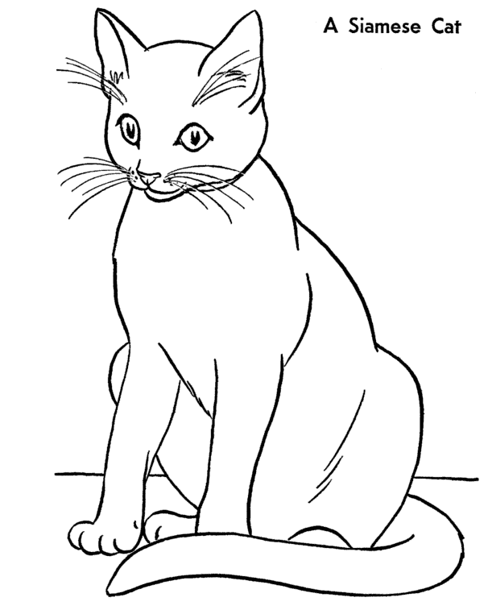
Breed: ________________________________________________________

5 specific/interesting facts about the cat breed:

