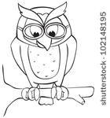

Qualities of a good teacher:

Qualities of a good student:

**“Owl” About Me!**



a few of my

favorites

animal ____________________________

color ___________________

food _______________________________

thing to do on the weekend _______________________________________

tv show/movie _______________________________________

Person I look up to:

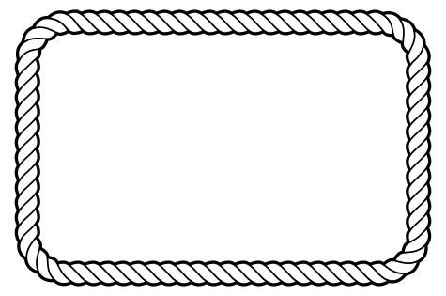

Did you know?

Something most people don’t know about me:

__________________________________________________________________________________________________________________________________________



**FACTS About Me**

**Name _____________________________________**

**Age __________**

**Grade ____________**

**Members of my family ____________________________________________**

**When I grow up I want to be _______________**



My hobbies/where I spend my free time:

1.__________________________________________

2.__________________________________________

3.__________________________________________