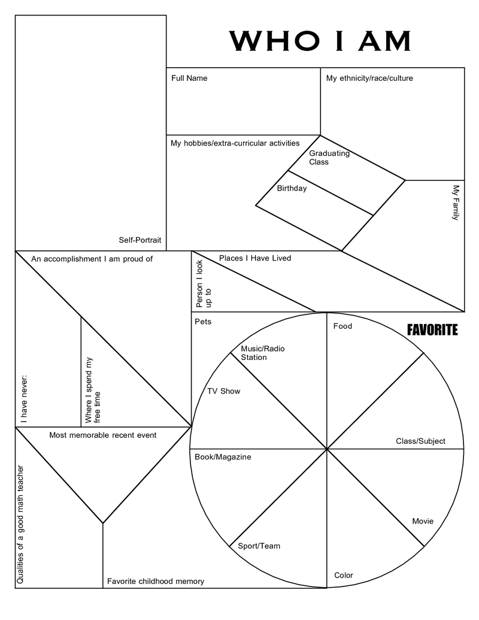

Qualities of a good teacher

Farm Animal